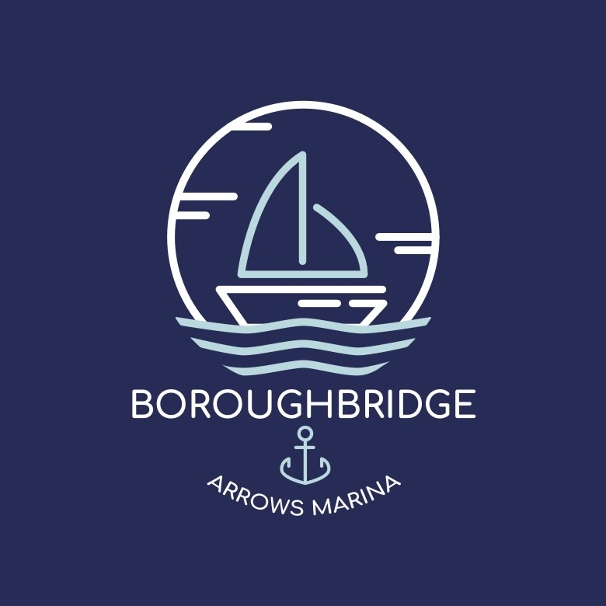

Payment Information

Address | Boroughbridge Arrows Marina Limited, Marina Lane, Boroughbridge, North Yorkshire, YO51 9GE.
Name | MR W BROWN
Sort Code | 40-47-31
Account Number | 65283434

